Project Design Phase

Proposed Solution Template
Project Title | DarshanEase: A Smart Temple Darshan Booking System Using MERN Stack
Team ID | ALITS-CSD-2026-DarshanEase
Team Members | Salapala Tharun Kumar Reddy (Team Leader); A. Goutham; M. Siva Prasad; M. Akhila; K. Hemalatha
College | Anantha Lakshmi Institute of Technology and Sciences (ALITS)
Academic Year | 2026

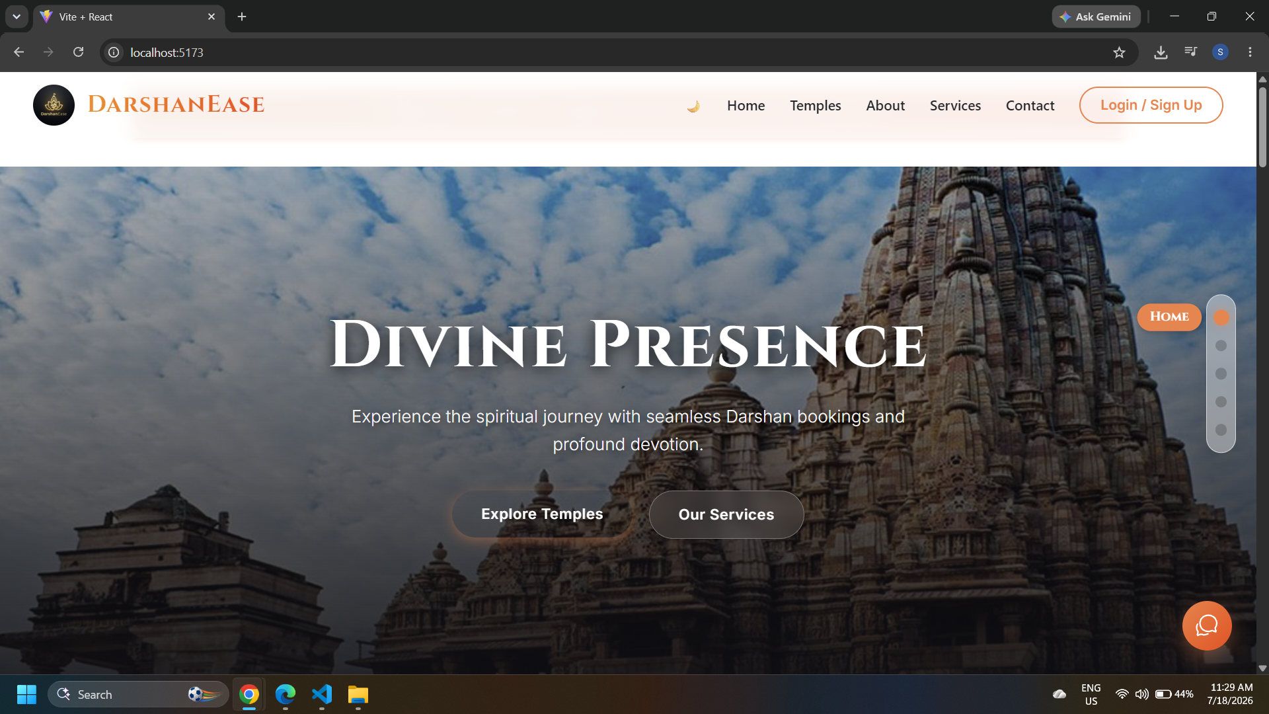
Figure: DarshanEase home page — the proposed solution in action
S.No | Parameter | Description
1 | Problem Statement | Devotees lack a unified platform to check temple darshan slot availability, book in advance, and plan their travel, resulting in long queues, missed slots, and disconnected trip planning.
2 | Idea / Solution description | DarshanEase is a MERN-stack web application that lets devotees register, browse temples, book darshan slots with instant confirmation, view booking history, and plan bus/train/flight journeys, while admins manage temples, slots, and bookings from a dedicated dashboard.
3 | Novelty / Uniqueness | Combines darshan slot booking and multi-modal journey planning in one platform, rather than treating them as separate concerns handled by different apps or manual processes.
4 | Social Impact / Customer Satisfaction | Reduces physical crowding and waiting time at temples, gives elderly and first-time visitors a simple, reliable way to plan visits, and improves transparency for devotees and administrators alike.
5 | Business Model (Revenue Model) | Freemium model for devotees; potential revenue through temple partnership/listing fees, premium priority-slot booking, and commission on integrated travel bookings.
6 | Scalability of the Solution | The three-tier MERN architecture and MongoDB's horizontal scaling allow DarshanEase to onboard additional temples, regions, and concurrent users without redesigning the core system.

